Test Case: tc003_SPX_Dev5_Crear_Requisicion_Spot_Tipo_Cobro_CC_Urgent
Step 1 - Enter username and password and click to button Enter : Credentials Entered
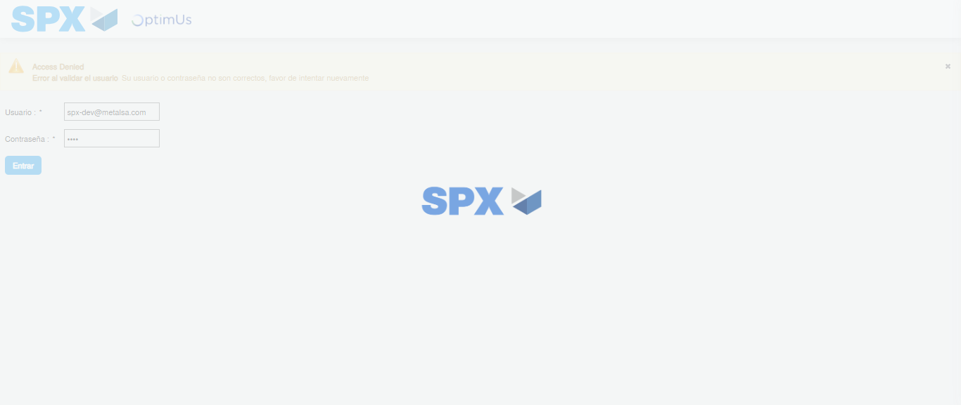Image file-name: QC_Testing-tc003_SPX_Dev5_Crear_Requisicion_Spot_Tipo_Cobro_CC_Urgent-1783358329589

Step 2 - Select to UEN and Access to Spot Buy Requisitions : UEN Correctly selected and Correct access
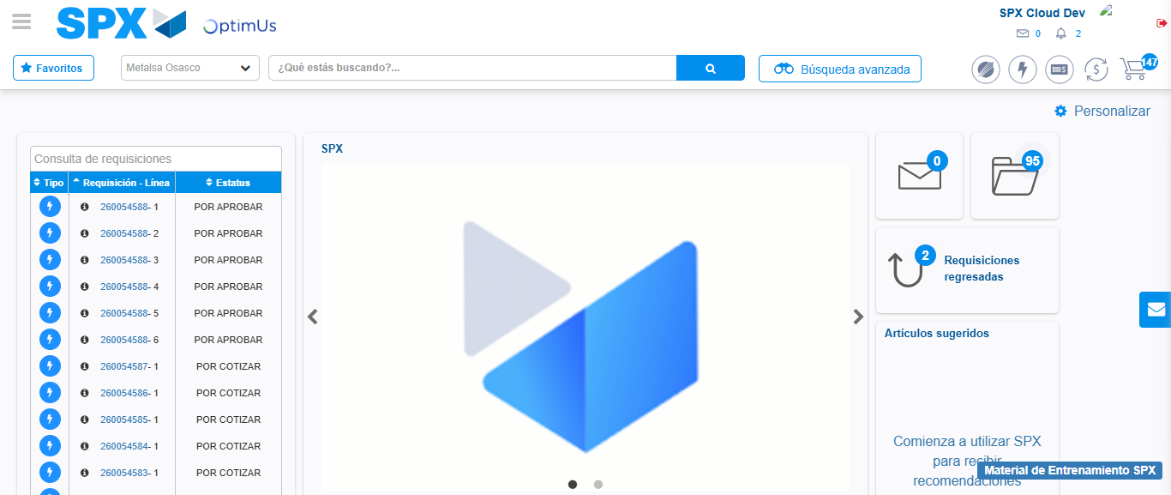Image file-name: QC_Testing-tc003_SPX_Dev5_Crear_Requisicion_Spot_Tipo_Cobro_CC_Urgent-1783358355117

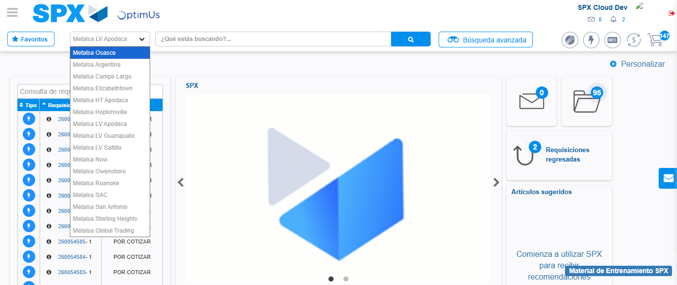Image file-name: QC_Testing-tc003_SPX_Dev5_Crear_Requisicion_Spot_Tipo_Cobro_CC_Urgent-1783358358013

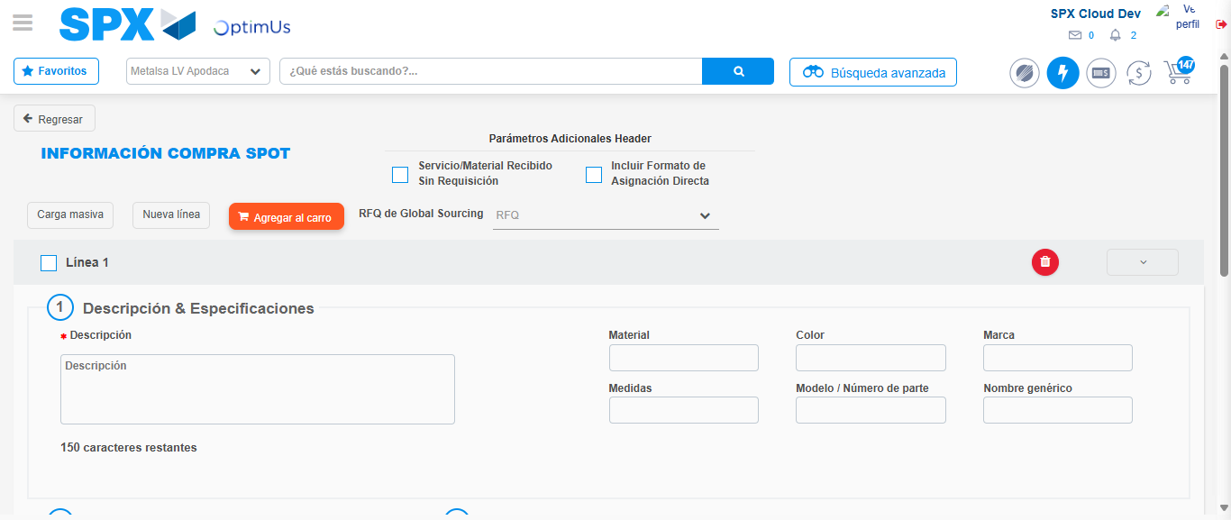Image file-name: QC_Testing-tc003_SPX_Dev5_Crear_Requisicion_Spot_Tipo_Cobro_CC_Urgent-1783358377851

Step 3 - Data Capture Spot Buy Requisition: Data captured correctly
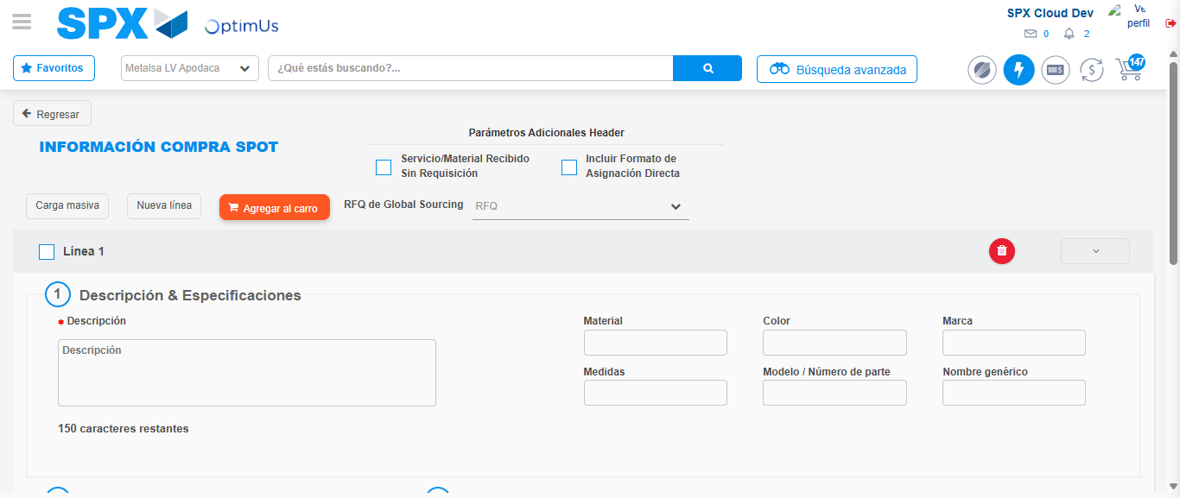Image file-name: QC_Testing-tc003_SPX_Dev5_Crear_Requisicion_Spot_Tipo_Cobro_CC_Urgent-1783358378175

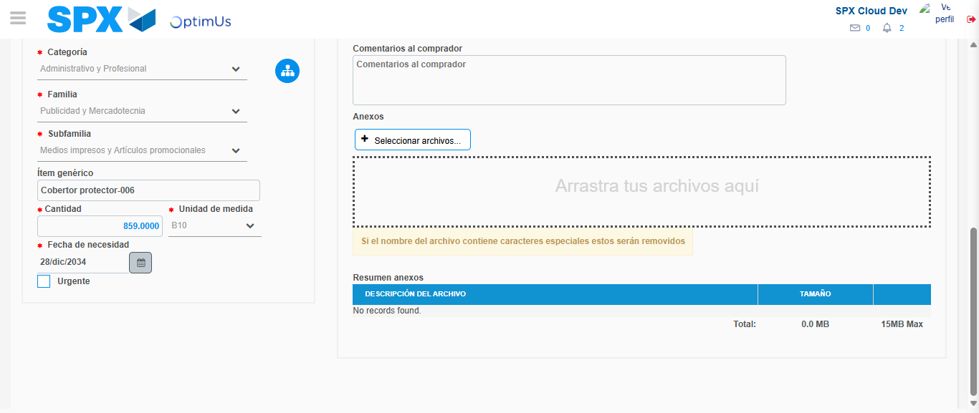Image file-name: QC_Testing-tc003_SPX_Dev5_Crear_Requisicion_Spot_Tipo_Cobro_CC_Urgent-1783358391343

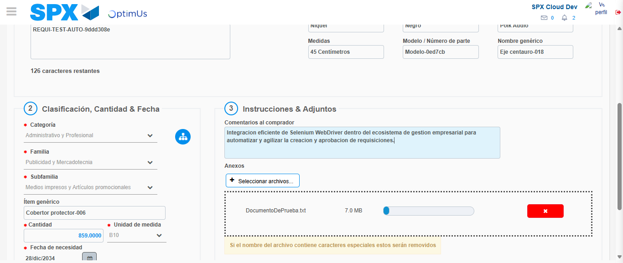Image file-name: QC_Testing-tc003_SPX_Dev5_Crear_Requisicion_Spot_Tipo_Cobro_CC_Urgent-1783358392381

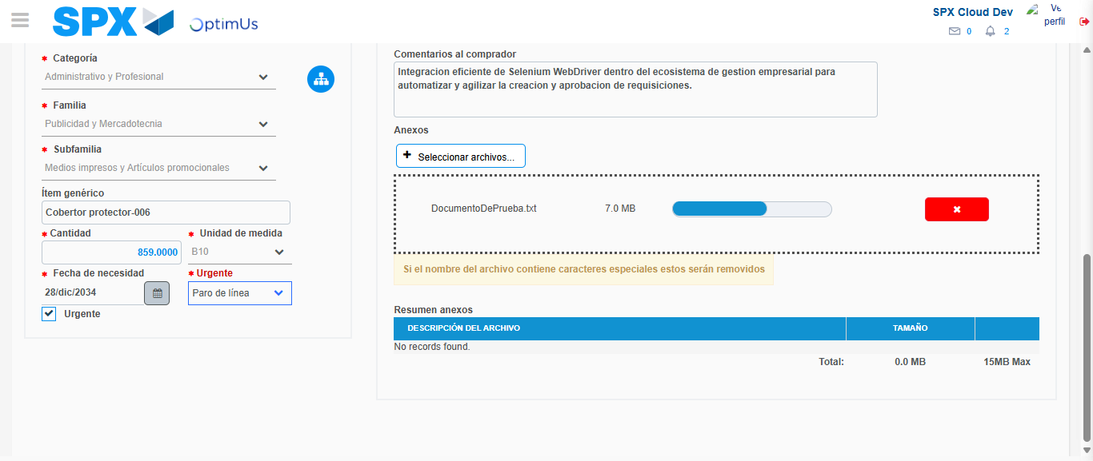Image file-name: QC_Testing-tc003_SPX_Dev5_Crear_Requisicion_Spot_Tipo_Cobro_CC_Urgent-1783358396435

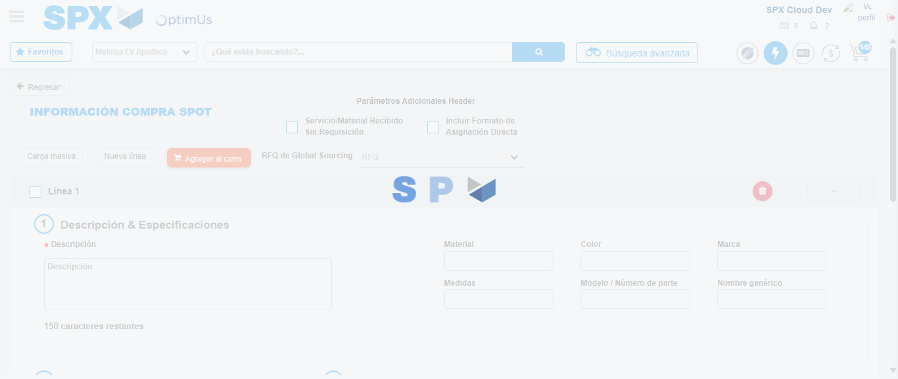Image file-name: QC_Testing-tc003_SPX_Dev5_Crear_Requisicion_Spot_Tipo_Cobro_CC_Urgent-1783358399345

Step 7 - Return to Main Page SPX : Return to Main Page SPX
Image file-name: QC_Testing-tc003_SPX_Dev5_Crear_Requisicion_Spot_Tipo_Cobro_CC_Urgent-1783358355117

Image file-name: QC_Testing-tc003_SPX_Dev5_Crear_Requisicion_Spot_Tipo_Cobro_CC_Urgent-1783358358013

Image file-name: QC_Testing-tc003_SPX_Dev5_Crear_Requisicion_Spot_Tipo_Cobro_CC_Urgent-1783358377851

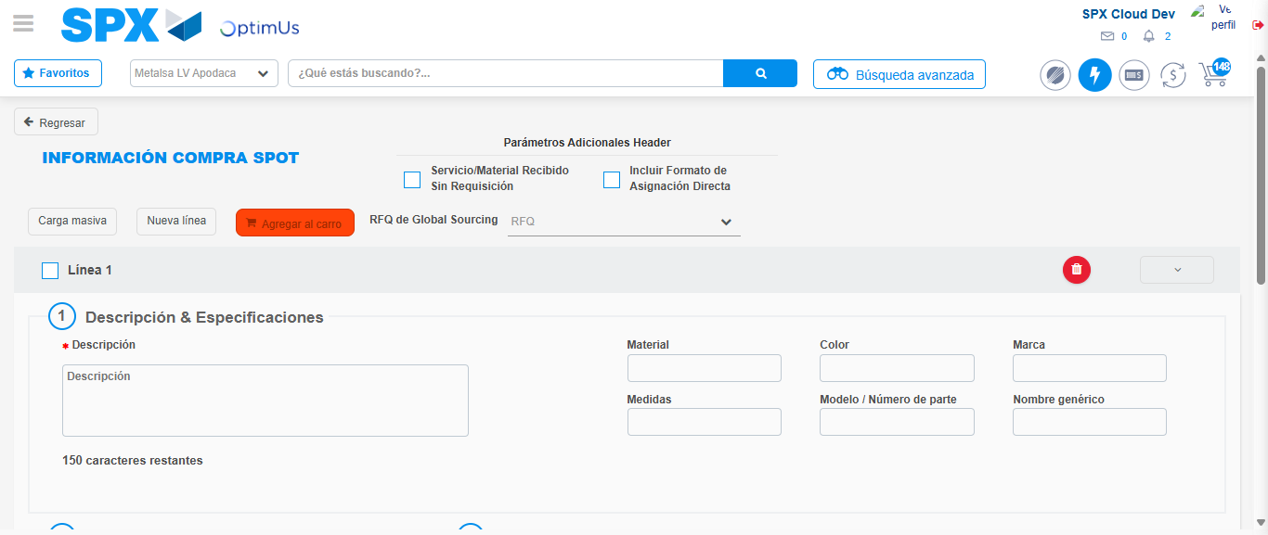Image file-name: QC_Testing-tc003_SPX_Dev5_Crear_Requisicion_Spot_Tipo_Cobro_CC_Urgent-1783358401665

Image file-name: QC_Testing-tc003_SPX_Dev5_Crear_Requisicion_Spot_Tipo_Cobro_CC_Urgent-1783358401855

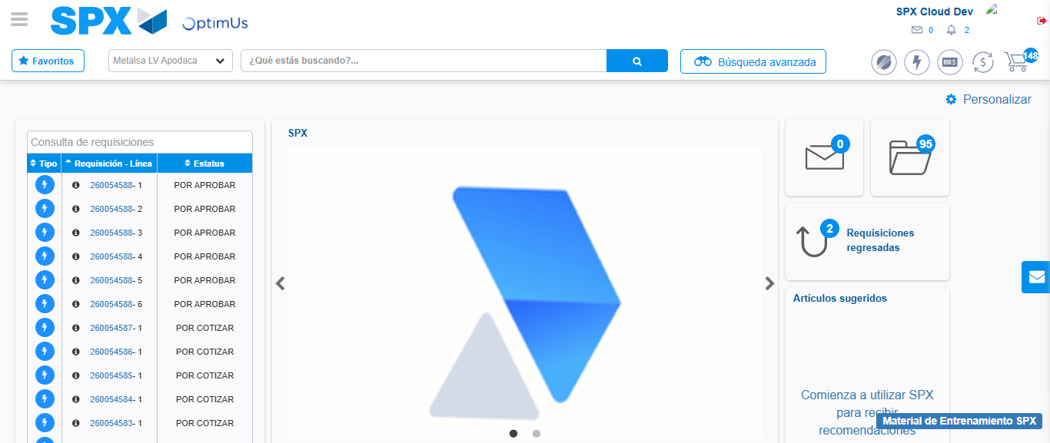Image file-name: QC_Testing-tc003_SPX_Dev5_Crear_Requisicion_Spot_Tipo_Cobro_CC_Urgent-1783358423287

Step 8 - Log Out : Log Out SPX
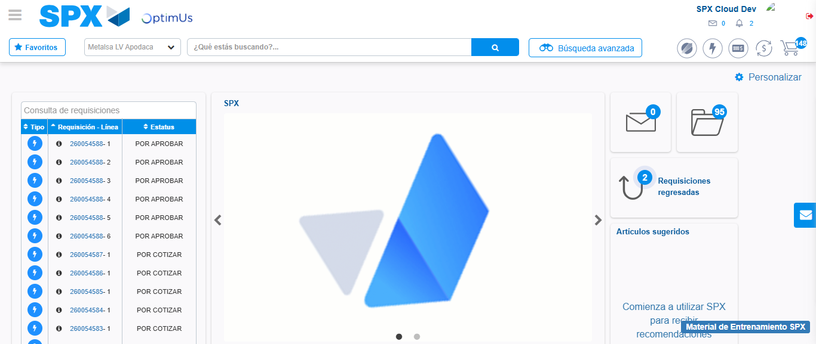Image file-name: QC_Testing-tc003_SPX_Dev5_Crear_Requisicion_Spot_Tipo_Cobro_CC_Urgent-1783358423585

